Queer Yeshiva at Limmud 5783

This is the first part of our sentence. It introduces which of our Sages are speaking, and the topic they are speaking on. In this case, who has the right to sit on the Sanhedrin [a Jewish judicial court] and therefore rule on life-and-death cases. We have put our translation down below.

אָמַר רַב יְהוּדָה אָמַר רַב אֵין מוֹשִׁיבִין בְּסַנְהֶדְרִין אֶלָא מִי שְׁיוֹדֵעַ

Rav Yehuda said that Rav said: ׳they [judges] shall not sit in the Sanhedrin unless they know…’

Translate this section as best you can. Find all the meanings of every word.
לְטַהֵר אֶת הַשֶּרֶץ מִן הַתּוֹרָה

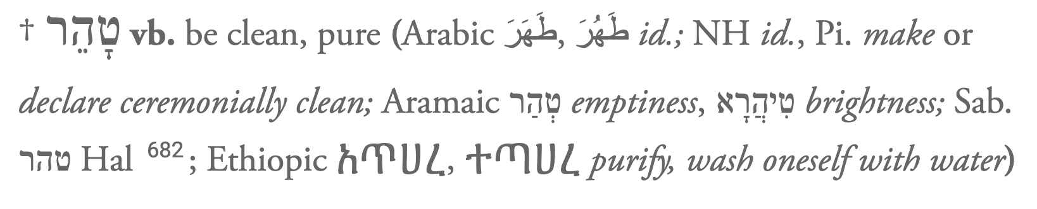
First word: לְטַהֵר
Preposition: to, for – לְ
Second word: אֶת
This is a word we don’t have an English equivalent for - it is used to indicate that the next word is the direct object of the sentence, i.e. the thing the verb is happening to.
Third word: הַשֶּרֶץ
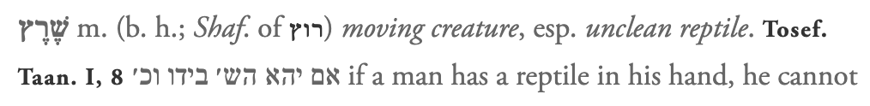
הַ – the definite article [the]
Fourth word: מִן
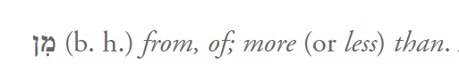
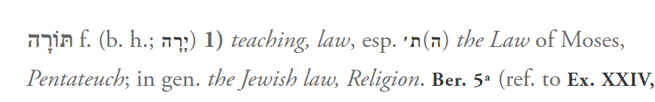
Fifth word: הַתּוֹרָה

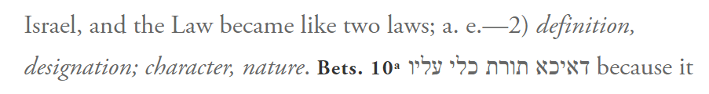
הַ – the definite article [the]
But what does Torah actually mean? All Hebrew words are built from a root which holds the various meanings of all the nouns and verbs that are made from it. The root for תּוֹרָה is ירה:
The תּ at the beginning is a feminine noun-ifier.

Kra for Sanhedrin 17a/b
Leviticus 11:29–31 | ויקרא יא:כט–לא
²⁹ The following shall be unclean for you from among the things that swarm on the earth: the mole, the mouse, and great lizards of every variety; ³⁰ the gecko, the land crocodile, the lizard, the sand lizard, and the chameleon. ³¹ Those are for you the unclean among all the swarming things; whoever touches them when they are dead shall be unclean until evening. | ^{כט} וְזֶה לָכֶם הַטָּמֵא בַּשֶּׁרֶץ הַשֹּׁרֵץ עַל־הָאָרֶץ הַחֹלֶד וְהָעַכְבָּר וְהַצָּב לְמִינֵהוּ׃ ^{ל} וְהָאֲנָקָה וְהַכֹּחַ וְהַלְּטָאָה וְהַחֹמֶט וְהַתִּנְשָׁמֶת׃ ^{לא} אֵלֶּה הַטְּמֵאִים לָכֶם בְּכָל־הַשָּׁרֶץ כָּל־הַנֹּגֵעַ בָּהֶם בְּמֹתָם יִטְמָא עַד־הָעָרֶב׃

